Project Design Phase-II Data Flow Diagram & User Stories
Date | 4 FEB 2026
Team ID | LTVIP2026TMIDS87433
Project Name | Rain Prediction Pipeline Flask
Maximum Marks | 4 Marks

Data Flow Diagrams:
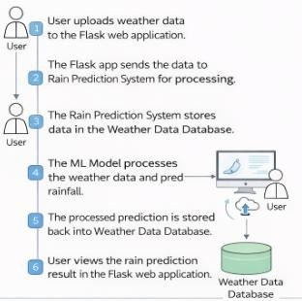
A Data Flow Diagram (DFD) is a traditional visual representation of the information flows within a system. A neat and clear DFD can depict the right amount of the system requirement graphically. It shows how data enters and leaves the system, what changes the information, and where data is stored.
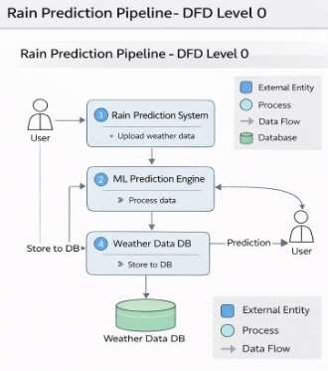
User Stories:
Use the below template to list all the user stories for the product.

User Type | Functional  Requirement (Epic) | User Story Number | User Story / Task | Acceptance criteria | Priority | Release
User (Web) | Registration | USN-1 | As a user, I can register for the application by entering my email, password, and confirming my password. | I can access my account / dashboard | High | Sprint-1
User (Web) | Login | USN-2 | As a user, I will receive confirmation email once I have registered for the application | I can receive confirmation email & click confirm | High | Sprint-1
User (Web) | Data Input | USN-3 | As a user, I can upload weather data through the Flask interface. | Weather data is accepted without errors. | High | Sprint-2
User (Web) | Prediction | USN-4 | As a user, I can submit weather inputs and receive rain prediction results. | Prediction is displayed on screen. | High | Sprint-1
User (Web) | View Results | USN-5 | As a user, I can view rainfall prediction clearly on the dashboard. | Prediction result is readable and accurate. | High | Sprint-1
User (Web) | Data Storage | USN-6 | As a user, I want prediction data to be stored for later reference. | Data saved in Weather Database. | Medium | Sprint-2
Student / Analyst | Model Understanding | USN-7 | As a learner, I want to understand how ML processes weather data. | ML workflow is visible in project structure. | Medium | Sprint-2
Admin | System Management | USN-8 | As an admin, I can manage datasets and model files. | Admin can update datasets/models. | Medium | Sprint-2

